ILLINOIS DEPARTMENT SALES ITEMS

Item #1 Item #2 Item #3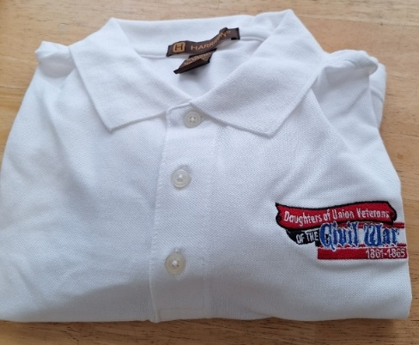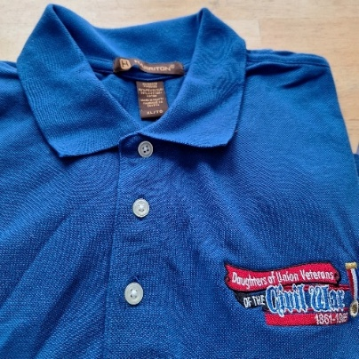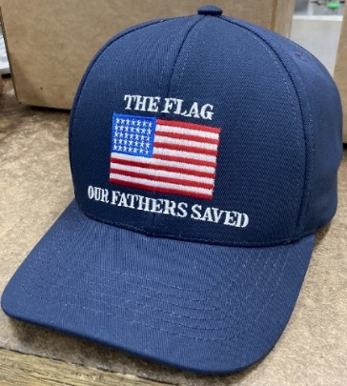

Item #4 Item #5 Item #6 Item #7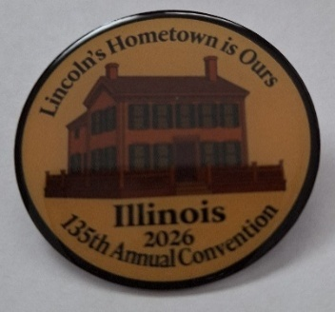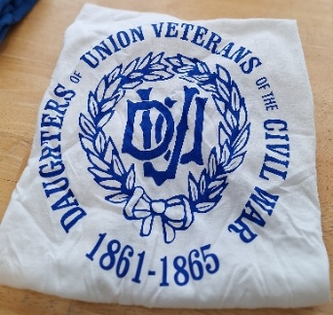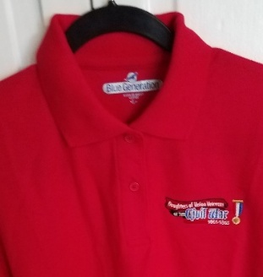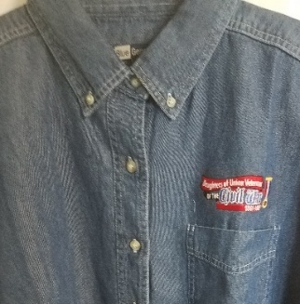

Item #1 White Polo shirt Sizes S-4XL $40.00 ea Size____Total$_______

Item #2 *Royal* Blue Polo Sizes S-4XL $40.00 ea Size_____Total_______

Item #3 Navy Blue Baseball Cap Made in USA $30.00 ea Qty_____ Total_______

Item #4 135th Convention Pin/Illinois $20.00 ea Qty__ _ Total_______

Item #5 White Cotton DUVCW T-Shirt $30.00 ea Size_____Total_______

*Available in sizes S- 4XL*

Item #6 Red Polo Shirt *Sizes S-4XL* $40.00 eaSize___ Total_______

Item #7 Blue Denim Long Sleeve Shirt $40.00 ea Size______Total_______

*Sizes S-4XL*

Sub-total for merchandise ordered ___________

Shipping: One item is $5.00; Two items is $7.00; 3 or more items $10.00. Shipping______________________

Check Number__________ **Total Order**________________

Make checks payable to**: DUVCW Illinois** and mail to Norma Fiedler, 2749 County Road 1600 E, Rantoul, IL. 61866

Mail order to:

Name_____________________________Email Address_________________________

Mailing Address_________________________________________________________

City__________________________________State__________Zip Code___________

Phone number_________________________________________________________

Thank you for your support. Please allow 4-6 weeks to receive order.