ILLINOIS DEPARTMENT SALES ITEMS
Item #1 Item #2 Item #3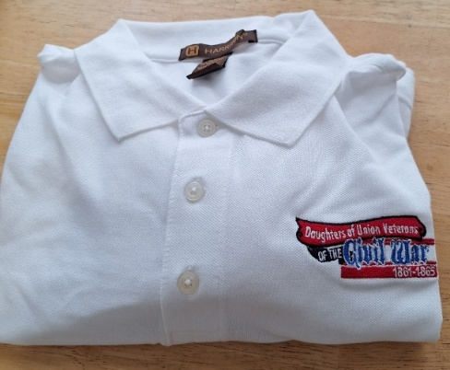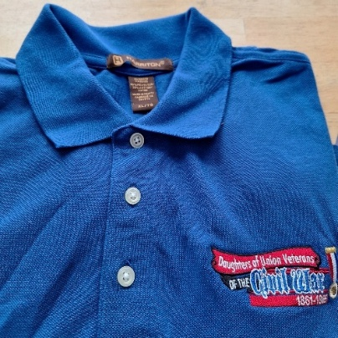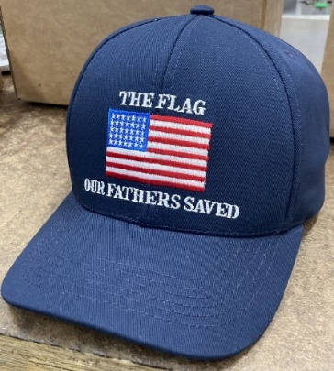
Item #4 Item #5 Item #6 Item #7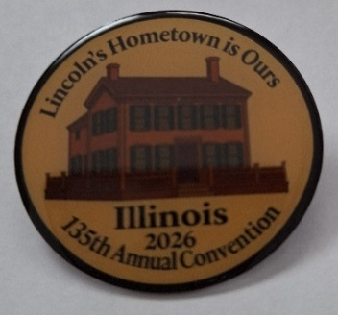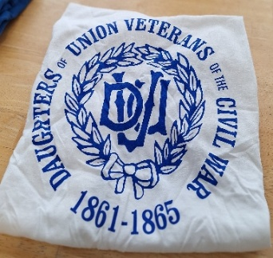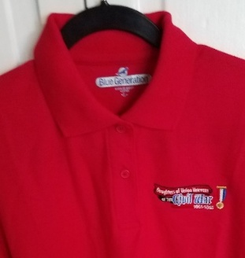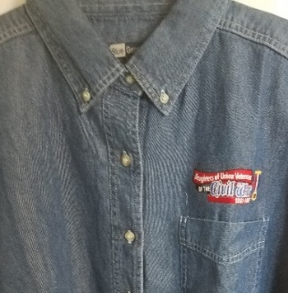
Item #1 White Polo shirt Sizes S-4XL $40.00 ea Size____Total$_______
Item #2 Royal Blue Polo Sizes S-4XL $40.00 ea Size_____Total_______
Item #3 Navy Blue Baseball Cap Made in USA $30.00 ea Qty_____ Total_______
Item #4 135th Convention Pin/Illinois $20.00 ea Qty__ _ Total_______
Item #5 White Cotton DUVCW T-Shirt $30.00 ea Size_____Total_______
Available in sizes S- 4XL
Item #6 Red Polo Shirt Sizes S-4XL $40.00 ea Size___ Total_______
Item #7 Blue Denim Long Sleeve Shirt $50.00 ea Size______Total_______
Sizes S-4XL
Sub-total for merchandise ordered ___________
Shipping: One item is $8.00; Two items is $12.00; 3 or more items $15.00. Shipping______________________
Check Number__________ Total Order________________
Make checks payable to: DUVCW Illinois and mail to Norma Fiedler, 2749 County Road 1600 E, Rantoul, IL. 61866
Mail order to:
Name_____________________________Email Address_________________________
Mailing Address_________________________________________________________
City__________________________________State__________Zip Code___________
Phone number_________________________________________________________

Thank you for your support. Please allow 4-6 weeks to receive order.
Updated 11/01/25

